Sequential Development and Performance Evaluation of a Low-Viscosity Textile Lubricant Based on Hydrotreated and Dewaxed I-8 Base Oil
Zafar Davletov*, Shuhratqodir Gulomov, Sherzod Mengliyev, Nargisa Igamkulova
Tashkent Institute of Chemical Technology, Tashkent 100011, Uzbekistan
*Corresponding author: zdavletov297@gmail.com
Hydrotreated and dewaxed I-8 mineral oil provides the low viscosity and chemical cleanliness required for textile processing, but the tested stock showed limited boundary lubrication, fibre wetting, and antistatic response. A four-component package containing a trimethylolpropane ester, a fatty-alcohol ethoxylate, an oil-dispersible alkylbenzene-sulfonate concentrate, and 2,6-di-tert-butyl-4-methylphenol was added sequentially to produce B0–F4. The samples were evaluated by physicochemical analysis, ATR-FTIR spectroscopy, four-ball tribology, contact angle, surface resistivity, water separation, and washability. Relative to B0, F4 reduced friction coefficient from 0.098 to 0.077, wear scar diameter from 0.62 to 0.45 mm, contact angle from 78.6° to 48.1°, and surface resistivity from 4.8 × 10¹¹ to 4.9 × 10¹⁰ Ω/sq. Cleaned ATR-FTIR spectra retained the paraffinic bands and showed additive-associated carbonyl and C–O–C/sulfonate-related absorption in F4. Residual emulsion and residual oil after washing also decreased. Because total additive concentration increased stepwise, the B0–F4 trend represents cumulative package performance rather than quantified synergy. F4 is the best-performing laboratory candidate among the tested formulations; factorial design and pilot textile trials remain necessary for optimisation and industrial validation.
  - Introduction
Textile spinning oils perform several functions at the same time. They must reduce fibre–metal and fibre–fibre friction, promote uniform spreading over the fibre surface, dissipate electrostatic charge, remain stable during processing, and be removable during subsequent scouring. Proffitt and Patterson (1988) described surfactants, lubricants, emulsifiers, and antistatic agents as the main interfacial components of textile finishes. Forster et al. (2014) likewise emphasised that lubricity, scourability, and compatibility with the processed fibre must be considered together rather than as independent properties.
Hydrotreated and dewaxed mineral oils are attractive because they are industrially available, thermally stable, and can be produced with low sulfur and aromatic contents. Refining also controls viscosity index, pour point, and hydrocarbon distribution (Lindemann, 2014). Wang et al. (2006) showed that hydroisomerisation and dewaxing alter lube-oil composition, while Porfiryev et al. (2020) demonstrated that base-oil chemistry influences low-temperature and operational behaviour. The tested I-8 stock combined favourable cleanliness and fluidity with weak interfacial and tribological performance, supporting the use of a multifunctional additive package.
Package effectiveness depends on both component function and compatibility. Polar esters support adsorption and boundary-film formation, whereas nonionic surfactants improve spreading and interfacial organisation. He et al. (2018) related friction-modifier performance to adsorption and film structure. Somers et al. (2013) showed that miscibility and molecular architecture govern antiwear behaviour, and Rahman and Eastoe (2022) linked surfactant-oil structure to self-assembly in non-polar media. Fang et al. (2022) connected surfactant adsorption with dynamic lubrication, while Sarno et al. (2021) reported lower friction and wear in a surfactant-assisted mineral-oil system.
A textile lubricant cannot be assessed by a steel-on-steel tribological test alone. Finish concentration affects inter-fibre cohesion and the response to washing (Lindström et al., 2020), while poor electrostatic control can destabilise high-speed fibre processing (Hufenus et al., 2020). Electrical measurements are also sensitive to specimen conditioning and electrode geometry (Xie et al., 2024). A meaningful screening programme should therefore combine friction, wear, wetting, electrical response, water separation, and washability under controlled conditions.
Few studies have applied this integrated approach to a low-viscosity hydrotreated and dewaxed I-8 oil derived from Central Asian crude. The objective of the present work was to determine how sequential addition of four complementary additive classes influenced the physicochemical, tribological, and textile-relevant behaviour of this base stock. The B0–F4 sequence was designed as a practical formulation-development study. It identifies the best-performing composition among the tested samples, but it does not isolate individual interaction terms; quantified synergy and industrial spinning suitability are therefore outside the scope of the present study.
  - Materials and methods
    - Materials and formulation design
A composite sample from one production batch of hydrotreated and dewaxed I-8 mineral oil was used as B0. Its refinery certificate reported 0.008 wt % sulfur, 6.9 wt % aromatic hydrocarbons, and a kinematic viscosity close to 8 mm²/s at 40 °C. The package contained a technical-grade trimethylolpropane fatty-acid triester, a C12–C14 fatty-alcohol ethoxylate with 7–9 ethylene-oxide units, an oil-dispersible alkylbenzene sulfonate concentrate, and BHT. All additives and auxiliary reagents were commercial grade, manufactured in 2025, and sourced from several producers in China. They were used as received. Archived records retained chemical class, specification, origin, and manufacturing year, but not a single trade name or producer-specific lot code.
B0 contained no additive. F1 contained 0.80 wt % ester; F2 contained F1 plus 0.40 wt % nonionic surfactant; F3 contained F2 plus 0.30 wt % alkylbenzene sulfonate; and F4 contained F3 plus 0.20 wt % BHT. The total additive content in F4 was 1.70 wt %. For each sample, 500 g of oil was heated to 55 ± 5 °C and stirred at 500 rpm. Each component was dispersed for 15 min, followed by 30 min final homogenisation. The blends were cooled, transferred to amber containers, and equilibrated for 24 h at 23 ± 2 °C.
    - Physicochemical and spectroscopic characterisation
Kinematic viscosity at 40 and 100 °C, viscosity index, pour point, density at 20 °C, acid number, and flash point were determined according to ASTM D445, ASTM D2270, ASTM D97, ASTM D4052, ASTM D664, and ASTM D92, respectively. The same procedures were applied to B0 and F4. Sulfur and aromatic content for B0 were taken from the refinery certificate and were not treated as replicated performance measurements. These two parameters were not determined for F4.
Experimental ATR-FTIR spectra of B0 and F4 were recorded using a Shimadzu IRTracer-100 FTIR spectrometer equipped with an ATR accessory over 4000–400 cm⁻¹. During repeat acquisitions, pointwise transmittance variation was generally 0.5–0.7 percentage points and did not exceed 1.0 percentage point. In paired repeat analyses, the difference at the selected diagnostic bands did not exceed 0.15 percentage point. These values were used only as internal repeatability criteria and were not treated as substitutes for replicate performance data. For publication, the spectra were graphically cleaned to improve line visibility; no bands were added, removed, or shifted, and the relative spectral features were retained. Interpretation focused on bands near 2923, 2853, 1460, 1377, and 720 cm⁻¹, the ester carbonyl region near 1734 cm⁻¹, and the C–O–C/sulfonate-related region at 1150–1050 cm⁻¹.
    - Tribological and textile-relevant tests
Four-ball tests were performed according to ASTM D4172 (ASTM International, 2016) with 12.7 mm AISI E52100 steel balls, a load of 392 N, a rotational speed of 1200 rpm, a temperature of 75 °C, and a test duration of 60 min. The steady-state coefficient of friction over the final 30 min was used for comparison. After solvent cleaning, each wear scar was measured in two perpendicular directions and the arithmetic mean was reported. Three independent tests were conducted for every formulation.
Wetting and electrical measurements used desized and scoured plain-woven cotton fabric of approximately 120 g/m². Specimens were conditioned for 24 h at 21 ± 1 °C and 65 ± 2 % relative humidity according to ASTM D1776 (ASTM International, 2020). A 5 µL droplet was placed on the fabric and the mean of the left and right contact angles was recorded after 5 s at five positions. For electrical testing, separate specimens were dosed to an oil add-on of 1.00 ± 0.05 wt % and equilibrated for 2 h. Oil add-on was calculated as 100(mtreated - mdry)/mdry. Surface resistivity was measured according to AATCC TM76 (AATCC, 2018) with parallel electrodes at 500 V DC, using the reading after 60 s and the cell geometry factor. Five specimens were tested.
Water separation was evaluated by a modified ASTM D1401-based procedure (ASTM International, 2019). Lubricant and distilled water (40 mL + 40 mL) were mixed for 5 min at 25 ± 1 °C, and the residual emulsion after 24 h was reported as 100(Vemulsion/Vtotal). Washability was measured on cotton treated to 1.00 ± 0.05 wt % oil add-on. Samples were washed for 15 min at 50 °C in 2 g/L nonionic detergent at a liquor ratio of 1:30, rinsed, dried, and extracted with n-hexane for 4 h. Residual oil was calculated relative to the initial applied oil after blank correction. Three specimens were tested.
    - Data treatment
Results are reported as mean ± standard deviation only where the complete replicate records were available. For surface resistivity, residual emulsion, and residual oil after washing, the archived dataset contained the reported central values but not the complete dispersion records; these results are therefore presented descriptively and are not used for significance testing. FTIR repeatability values were treated solely as instrument quality-control information. Relative improvement was calculated as 100(XB0 − XFi)/XB0 when a decrease indicated better performance, and surface resistivity was interpreted on a logarithmic scale. Because each formulation retained the previously added components and contained a progressively higher total additive concentration, no interaction coefficient, factorial analysis of variance, or synergy index was calculated.
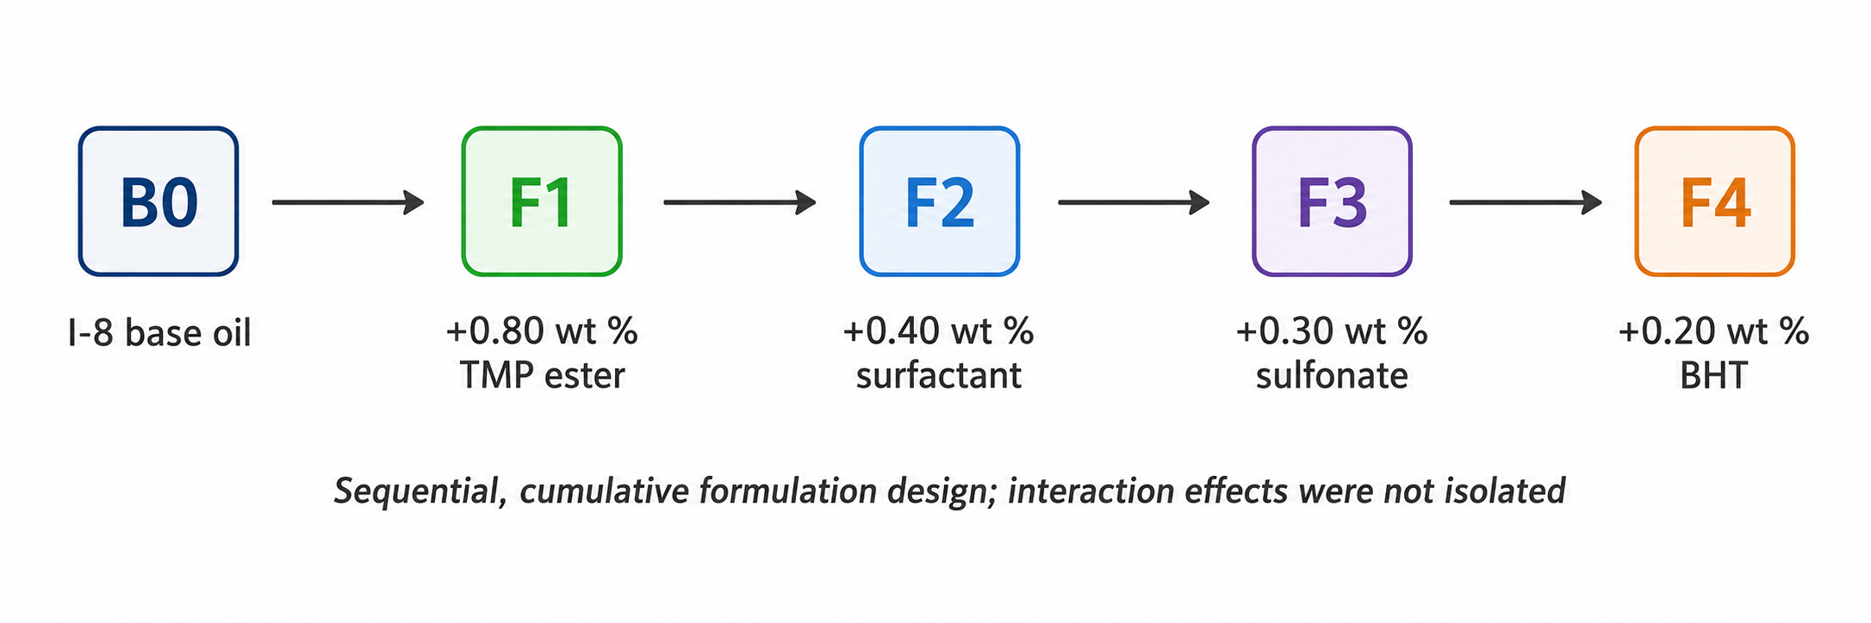
Figure 1: Sequential B0–F4 formulation design. Each stage retains all components introduced previously, so concentration and interaction effects are not separated.
  - Results and discussion
    - Physicochemical behaviour
The untreated I-8 oil showed the low viscosity and favourable low-temperature behaviour expected from a hydrotreated and dewaxed mineral stock, but it also produced the highest friction coefficient, wear scar diameter, contact angle, and surface resistivity among the tested samples. Because an untreated precursor and oils produced at different refining severities were not included, the study does not attribute these limitations directly to hydrotreating or dewaxing. B0 is used only as the formulation reference.
F4 retained the fluidity required for a low-viscosity textile lubricant (Table 1). Viscosity at 40 °C increased by 5.5 %, from 8.18 to 8.63 mm²/s, while viscosity index increased from 91 to 97. Pour point shifted from -15 to -18 °C, density rose from 0.832 to 0.836 g/cm³, acid number remained low at 0.05 mg KOH/g, and flash point increased from 164 to 170 °C. The package therefore altered functional behaviour without producing a substantially more viscous fluid. Sulfur and aromatic contents were not measured for F4.
Table 1: Physicochemical properties of the untreated base oil B0 and the complete formulation F4.
Property | Method | B0 | F4
Sulfur, wt % | Refinery certificate | 0.008 | n.d.
Aromatic fraction, wt % | Refinery certificate | 6.9 | n.d.
Kinematic viscosity at 40 °C, mm²/s | ASTM D445 | 8.18 ± 0.04 | 8.63 ± 0.05
Kinematic viscosity at 100 °C, mm²/s | ASTM D445 | 2.15 ± 0.02 | 2.24 ± 0.02
Viscosity index | ASTM D2270 | 91 | 97
Pour point, °C | ASTM D97 | -15 | -18
Density at 20 °C, g/cm³ | ASTM D4052 | 0.832 | 0.836
Acid number, mg KOH/g | ASTM D664 | 0.02 | 0.05
Flash point, °C | ASTM D92 | 164 | 170
n.d.: not determined in the present study.
    - ATR-FTIR analysis
The cleaned experimental ATR-FTIR spectra of B0 and F4 are dominated by paraffinic bands near 2923, 2853, 1460, 1377, and 720 cm⁻¹ (Figure 2). F4 additionally showed absorption near 1734 cm⁻¹, consistent with ester carbonyl stretching, and increased absorption at 1150–1050 cm⁻¹, where C–O–C and sulfonate-related vibrations may overlap. These additive-associated features remained weaker than the principal CH₂ absorptions, consistent with the total additive content of 1.70 wt %. The spectra support qualitative confirmation of incorporated functional groups but do not quantify additive concentration, interaction strength, or tribofilm formation.
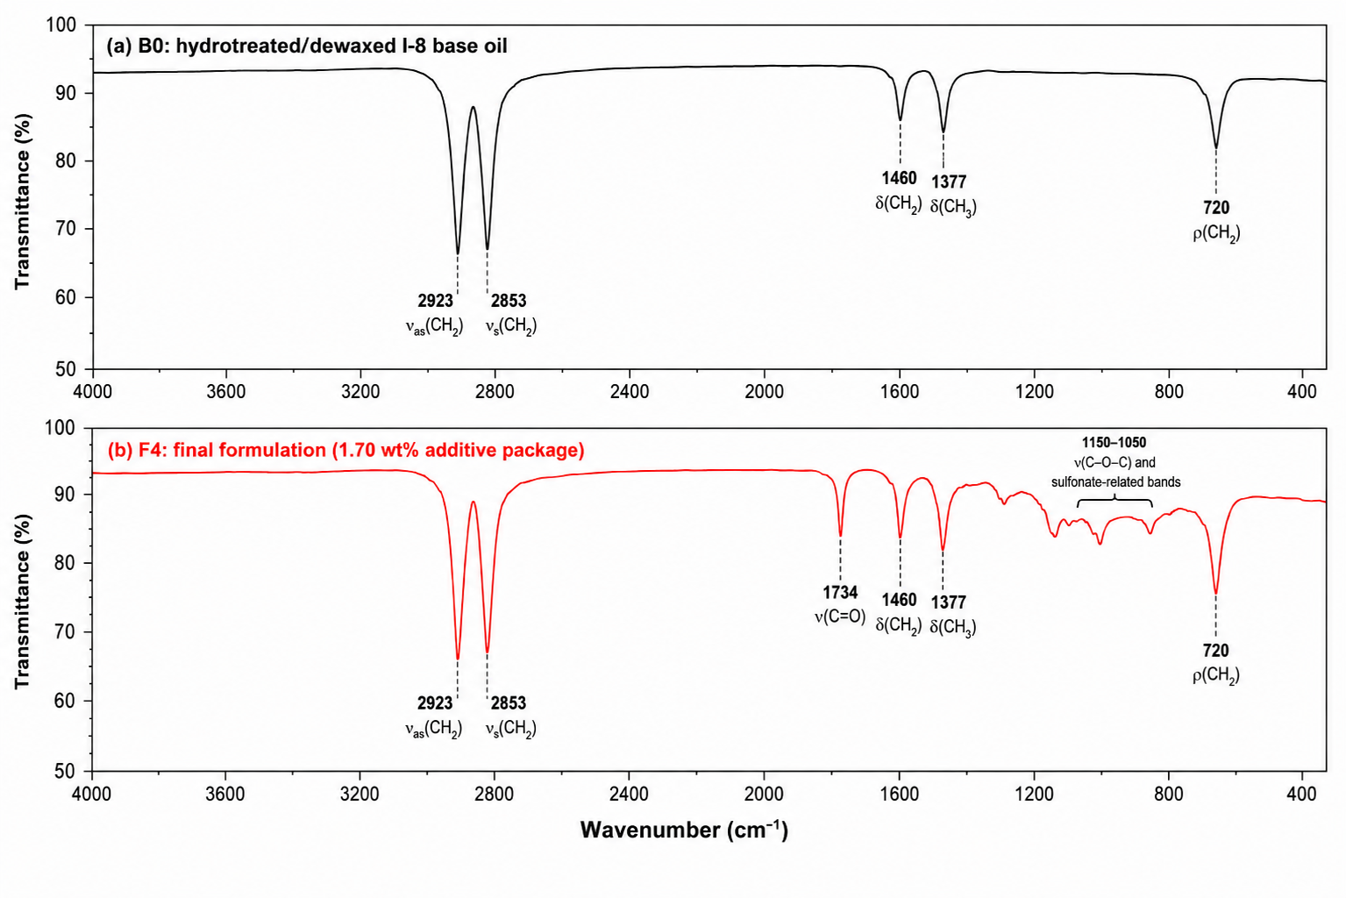
Figure 2: Cleaned and clarified experimental ATR-FTIR spectra of B0 and F4. Graphical cleaning was limited to presentation quality; the original band positions and relative spectral features were preserved.
    - Tribological response
Sequential package addition reduced coefficient of friction and wear scar diameter (Table 2 and Figure 3). F1 produced the first clear improvement, consistent with adsorption and boundary-film formation by the polar ester. F2 provided a further decrease, and the largest subsequent wear reduction occurred after the sulfonate-containing F3 stage. F4 gave the lowest values: 0.077 for friction coefficient and 0.45 mm for wear scar diameter, reductions of 21.4 % and 27.4 % relative to B0. The small F3-F4 difference is not assigned specifically to BHT because the antioxidant was not evaluated independently.
The improvement is comparable in magnitude with the maximum reductions reported by Sarno et al. (2021) for a different surfactant-assisted mineral-oil system, although additive chemistry and test conditions differ. Four-ball testing uses steel-on-steel contact and cannot reproduce yarn-guide geometry or surface chemistry. Yarn-metal friction and running-tension measurements are therefore required for application validation.
Table 2: Formulation composition and four-ball tribological results.
Sample | Composition | COF | WSD, mm
B0 | Base oil only | 0.098 ± 0.003 | 0.62 ± 0.02
F1 | B0 + 0.80 wt % TMP ester | 0.089 ± 0.002 | 0.57 ± 0.01
F2 | F1 + 0.40 wt % alcohol ethoxylate | 0.084 ± 0.002 | 0.54 ± 0.01
F3 | F2 + 0.30 wt % sulfonate | 0.079 ± 0.002 | 0.47 ± 0.01
F4 | F3 + 0.20 wt % BHT | 0.077 ± 0.002 | 0.45 ± 0.01
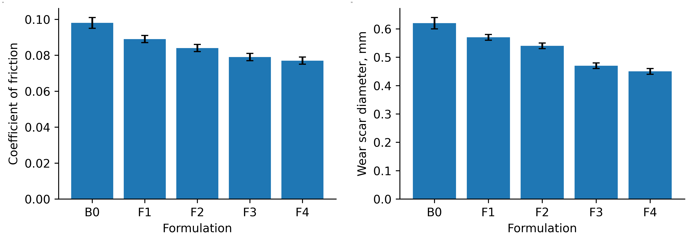
Figure 3: (a) Coefficient of friction and (b) wear scar diameter for B0–F4. Error bars represent standard deviation, n = 3.
    - Wetting, electrical response, and removability
Contact angle decreased from 78.6 ± 1.8° for B0 to 48.1 ± 1.1° for F4, a reduction of 38.8 % (Table 3). The largest single decrease occurred after addition of the polar ester, while the ethoxylated surfactant provided further improvement in spreading. Cotton is porous and absorbent, so the fixed 5 s value is a comparative screening measurement rather than an equilibrium contact angle. Dynamic spreading and capillary-uptake tests are needed for a fuller description of finish distribution.
Surface resistivity decreased from 4.8 × 10¹¹ to 4.9 × 10¹⁰ Ω/sq, corresponding to an 89.8 % reduction. The largest relative change followed incorporation of the sulfonate antistatic component, which is consistent with improved charge transport at controlled oil add-on. These conditioned-fabric measurements indicate an improved antistatic response, but they do not establish charge-decay behaviour under dynamic spinning conditions.
Residual emulsion after 24 h fell from 7.8 to 1.2 vol %, indicating improved phase separation in the modified test. Residual oil after washing decreased from 4.6 to 2.5 %, a 45.7 % reduction. The combined trend indicates improved downstream removability, although the cumulative design prevents assignment of the effect to a single component. Residual emulsion is used here as a demulsibility indicator; a lower value does not imply greater emulsion stability.
Table 3: Textile-relevant interfacial, electrical, and removability properties.
Sample | Contact angle, ° | Surface resistivity, Ω/sq | Residual emulsion, vol % | Residual oil, %
B0 | 78.6 ± 1.8 | 4.8 × 10¹¹ | 7.8 | 4.6
F1 | 66.2 ± 1.5 | 3.6 × 10¹¹ | 6.4 | 4.2
F2 | 58.7 ± 1.4 | 1.7 × 10¹¹ | 3.2 | 3.5
F3 | 50.4 ± 1.2 | 6.1 × 10¹⁰ | 1.5 | 2.8
F4 | 48.1 ± 1.1 | 4.9 × 10¹⁰ | 1.2 | 2.5
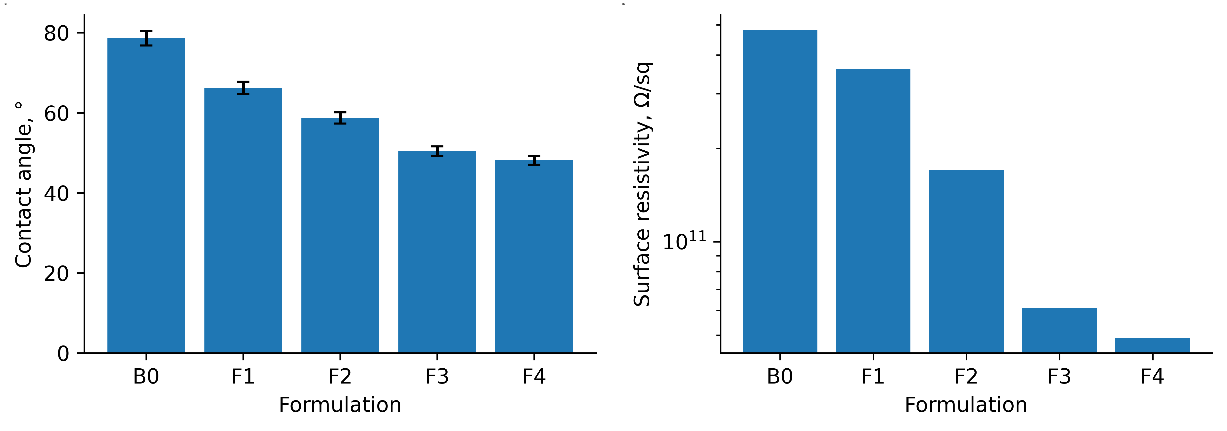
Figure 4: (a) Contact angle and (b) surface resistivity for B0–F4. Error bars in panel (a) represent standard deviation; surface-resistivity values in panel (b) are presented descriptively on a logarithmic scale.
    - Overall interpretation and limitations
The tested I-8 oil can serve as a platform for a multifunctional low-viscosity textile lubricant. F4 provided the best balance of friction, wear, wetting, electrical response, water separation, and washability among the five samples, but it is not mathematically optimised. Because total additive concentration increased at every stage, individual, concentration, and interaction effects cannot be separated. Single-additive controls, binary combinations, and factorial design are required before synergy can be claimed.
The contribution of BHT to oxidation stability was not measured. Yarn-metal friction, charge-decay rate, finish pick-up uniformity, pilot washing, and spinning-line performance were outside the present study. ATR-FTIR was used for qualitative band assignment only; quantitative compositional analysis would require instrument-exported data and validated calibration. Conclusions are therefore restricted to the reported laboratory screening results.
    - Practical formulation implications
F4 defines a practical laboratory formulation window rather than a final industrial recipe. At a total additive dosage of 1.70 wt %, viscosity at 40 °C increased by only 5.5 %, while low-temperature fluidity was retained. The sequence of measured changes is consistent with the ester-containing stage improving boundary lubrication, the ethoxylated surfactant supporting spreading, and the sulfonate-containing stage producing the largest decrease in surface resistivity. These trends provide a chemically coherent formulation rationale, but they cannot be assigned to isolated components because composition and total dosage changed simultaneously.
The simultaneous decreases in residual emulsion and residual oil after washing indicate that improved tribological and antistatic performance was not obtained at the expense of downstream removability. Before scale-up, the formulation should be benchmarked against a commercial textile oil at equal oil pick-up and assessed by yarn–metal friction, charge-decay, accelerated oxidation, and storage-stability tests. These measurements would convert the present screening results into an application specification while preserving the cautious interpretation required by the sequential experimental design.
  - Conclusions
A sequential four-component package improved the laboratory performance of hydrotreated and dewaxed I-8 base oil while preserving its low-viscosity character. Cleaned experimental ATR-FTIR spectra retained the main paraffinic bands and showed additive-associated carbonyl and C–O–C/sulfonate-related absorption in F4. The complete formulation reduced friction coefficient from 0.098 to 0.077, wear scar diameter from 0.62 to 0.45 mm, contact angle from 78.6° to 48.1°, and surface resistivity from 4.8 × 10¹¹ to 4.9 × 10¹⁰ Ω/sq. Residual emulsion and residual oil after washing also decreased. These results show cumulative package performance, not quantified synergy. F4 is the best-performing tested formulation; future work should include factorial design, oxidation and storage-stability testing, yarn-level tribology, charge-decay measurement, and pilot spinning trials.
Acknowledgments
The authors acknowledge the institutional laboratory facilities used in this study. No dedicated external grant funding was received for this work.
References
AATCC, 2018, AATCC TM76, Electrical resistivity of fabrics, American Association of Textile Chemists and Colorists, Research Triangle Park, NC, USA.
ASTM International, 2016, ASTM D4172-94(2016), Standard test method for wear preventive characteristics of lubricating fluid (four-ball method), West Conshohocken, PA, USA.
ASTM International, 2019, ASTM D1401-19, Standard test method for water separability of petroleum oils and synthetic fluids, West Conshohocken, PA, USA.
ASTM International, 2020, ASTM D1776/D1776M-20, Standard practice for conditioning and testing textiles, West Conshohocken, PA, USA.
Fang J., Bai P., Ouyang C., Liu C., Wen X., Li Y., Meng Y., Ma L., Tian Y., 2022, Influence of adsorption characteristics of surfactants sodium dodecyl sulfate and Aerosol-OT on dynamic process of water-based lubrication, Lubricants, 10, 147.
Forster C., Schweigkofler M., Zechel R., Lienhard R., 2014, Textile industry lubrication, Chapter In: Mang T. (Ed.), Encyclopedia of Lubricants and Lubrication, Springer, Berlin, Heidelberg, Germany, 2052-2092.
He X., Lu J., Desanker M., Invergo A.M., Lohr T.L., Ren N., Lockwood F.E., Marks T.J., Chung Y., Wang Q.J., 2018, Boundary lubrication mechanisms for high-performance friction modifiers, ACS Applied Materials & Interfaces, 10, 40203-40211.
Hufenus R., Gooneie A., Sebastian T., Simonetti P., Geiger A., Parida D., Bender K., Schäch G., Clemens F., 2020, Antistatic fibers for high-visibility workwear: Challenges of melt-spinning industrial fibers, Materials, 13, 2645.
Lindemann L., 2014, Mineral base oils, conventional refining, Chapter In: Mang T. (Ed.), Encyclopedia of Lubricants and Lubrication, Springer, Berlin, Heidelberg, Germany, 1188-1198.
Lindström K., Sjöblom T., Persson A., Kadi N., 2020, Improving mechanical textile recycling by lubricant pre-treatment to mitigate length loss of fibers, Sustainability, 12, 8706.
Porfiryev Y., Shuvalov S., Popov P., Kolybelsky D., Petrova D., Ivanov E., Tonkonogov B., Vinokurov V., 2020, Effect of base oil nature on the operational properties of low-temperature greases, ACS Omega, 5, 11946-11954.
Proffitt T.J., Patterson H.T., 1988, Oleochemical surfactants and lubricants in the textile industry, Journal of the American Oil Chemists' Society, 65, 1682-1694.
Rahman A., Eastoe J., 2022, The effects of surfactant and oil chemical structures on self-assembly in apolar media, Soft Matter, 18, 9133-9152.
Sarno M., Cirillo C., Senatore A., 2021, Anti-friction and anti-wear surfactant-assisted nano-onions stable formulations for lubricants, Chemical Engineering Transactions, 84, 169-174.
Somers A.E., Khemchandani B., Howlett P.C., Sun J., MacFarlane D.R., Forsyth M., 2013, Ionic liquids as antiwear additives in base oils: Influence of structure on miscibility and antiwear performance for steel on aluminium, ACS Applied Materials & Interfaces, 5, 11544-11553.
Wang Q., Ling H., Shen B., Li K., Ng S., 2006, Evaluation of hydroisomerization products as lube base oils based on carbon number distribution and hydrocarbon type analysis, Fuel Processing Technology, 87, 1063-1070.
Xie Z., Ventura H., Ardanuy M., 2024, A review of the electrical conductivity test methods for conductive fabrics, Textiles, 4, 284-308.

